ISCG7424 Mobile Software Development

Semester 2, 2022

**Assignment 2: Cocktail Planner User Guide**

Submitted by

Anna McColl

Prepared for Tariq Khan

Date Submitted: 14th November 2022

1.0 Table of Contents

2.0 Table of Figures 2

3.0 Introduction 3

4.0 Main Menu 3

5.0 Cocktail Ingredients 4

5.1 Add Ingredient 4

5.2 Ingredient Pantry 6

5.2.1 Update Ingredient 6

5.2.2 Delete Ingredient 7

6.0 Cocktail Recipes 8

6.1 All Cocktails 8

6.1.1 View Recipe 9

6.2 Favourite Cocktails 11

# 2.0 Table of Figures

Figure 1: Main Menu. 3

Figure 2: Add Ingredient. 4

Figure 3: Add Ingredient - Calendar Widget. 5

Figure 4: Ingredient Pantry. 6

Figure 5: Update Ingredient. 7

Figure 6: Delete Ingredient Dialog. 8

Figure 7: All Cocktails. 9

Figure 8: View Recipe. 10

Figure 9: Favourite Cocktails. 11

# 3.0 Introduction

This Cocktail Planner mobile application is not only a useful way to keep track of what alcohol a user has in their home, but also to catalogue which drinks their friends, family or other acquaintances like.

It contains a library to store information on which cocktail ingredients the user has in stock, as well as which cocktails are their favourites, and uses an API interface to retrieve cocktail recipes for the user to try.

# 4.0 Main Menu

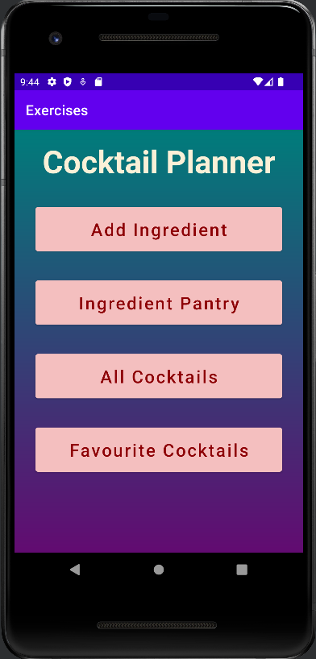

Figure : Main Menu.

The first screen that the user will see is the Main Menu (see figure 1). It comprises of four buttons. The first two buttons, *Add Ingredient* and *Ingredient Pantry*, are a catalogue system of ingredients to be used in the creation of cocktails. The *Favourite Cocktails* and *All Cocktails* buttons lead to cocktail recipes the user may wish to create.

Clicking on any of these buttons will take the user to the appropriate portion of the application.

# 5.0 Cocktail Ingredients

## 5.1 Add Ingredient

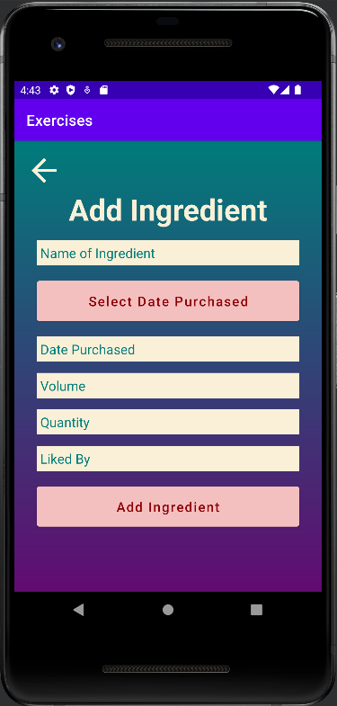

Figure : Add Ingredient.

The Add Ingredient form (see figure 2) contains fields for the user to fill out the name of the ingredient, the volume (for example, if the bottle is 1L, 750mL etc), the quantity of the ingredient, and who amongst their friends, family, or other acquaintances likes the particular ingredient.

There are three buttons on the screen, *Select Date Purchased*, *Add Ingredient* and the back arrow button in the upper left-hand corner.

The *Select Date Purchased* Button opens a calendar widget (see figure 3) for the user to select the date the ingredient was purchased, which will then populate the Date Purchased field.

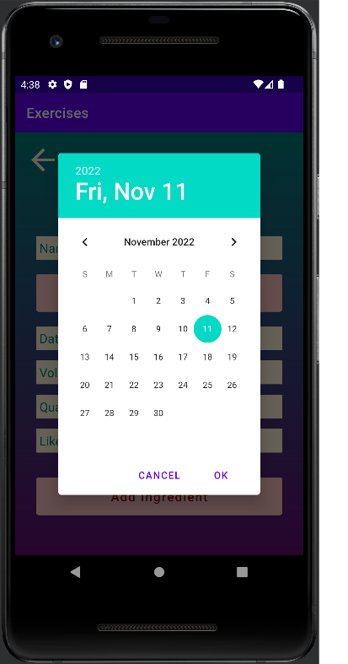

Figure : Add Ingredient - Calendar Widget.

The *Add Ingredient* button (see figure 2) will save the ingredient to the application database and return the user to the Main Menu.

The back arrow button (see figure 2) will also return the user to the Main Menu.

## 5.2 Ingredient Pantry

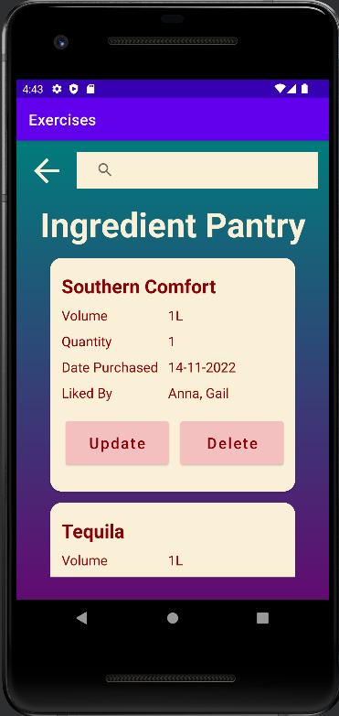

Figure : Ingredient Pantry.

The Ingredient Pantry (see figure 4) contains a list of all the ingredients that have been saved to the application database. The user can scroll through the list of ingredients and view the details that have been entered, and update or delete them by selecting the buttons in the listing.

At the top of the screen is a search bar that will search the name of an ingredient in the ingredients list, filtering the ingredients listed with each keystroke. Once the user starts typing, an *X* will appear at the right end of the search bar. By clicking on this, the user will clear the search query.

### 5.2.1 Update Ingredient

By clicking the *Update* button (see figure 4) on an ingredient’s listing in the Ingredient Pantry, the user will be taken to the Update Ingredient form (see figure 5). This will be prepopulated with information from the application database, as well as a back arrow button (in the upper left-hand corner), the *Change Date Purchased* button and the *Save* button. While all the other text fields are editable, the Date Purchased field can only be changed by clicking on the *Change Date Purchased* button. Clicking the *Save* button will update the application database.

Figure : Update Ingredient.

### 5.2.2 Delete Ingredient

Selecting the *Delete* button on the ingredient listing in the Ingredient Pantry, will open a dialog message asking the user for confirmation that they would like to delete the ingredient selected (see figure 6).

Selecting the *Cancel* option will return the user the Ingredient Panty with no action taken. Selecting *Yes* will delete the ingredient from the application’s database.

Figure : Delete Ingredient Dialog.

# 6.0 Cocktail Recipes

## 6.1 All Cocktails

By clicking on the *All Cocktails* button on the main menu a list of cocktails is brought up (see figure 7). Each listing contains the name of the cocktail, an image of the cocktail, and a button for the user to *View Recipe*.

At the top of the screen is a search bar that will search through the cocktail names, filtering the list with each keystroke. Once the user starts typing, an *X* will appear at the right end of the search bar. By clicking on this, the user will clear the search query.

There is also a back arrow which will return the user to the Main Menu.

Figure : All Cocktails.

### 6.1.1 View Recipe

By clicking on the View Recipe button in the All Cocktails listing, the user is taken to the recipe for the selected cocktail.

There are only two buttons on this screen, the back arrow button in the top left corner, and the *Add To Favourites* button. If the recipe has previously been added to the Favourites list, the button changes to *Remove From Favourites* (see figure 8).

The back arrow button will return the user to the previous list view.

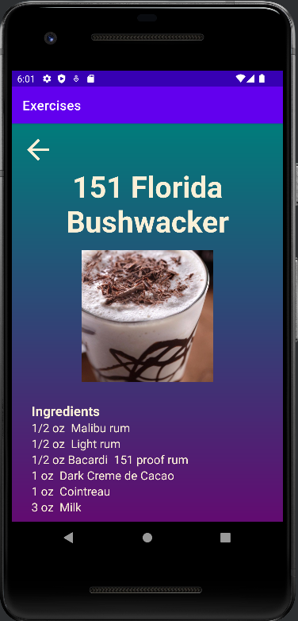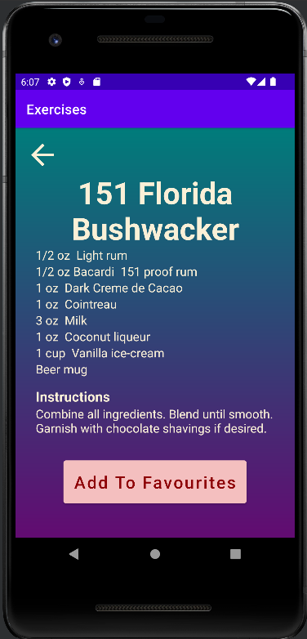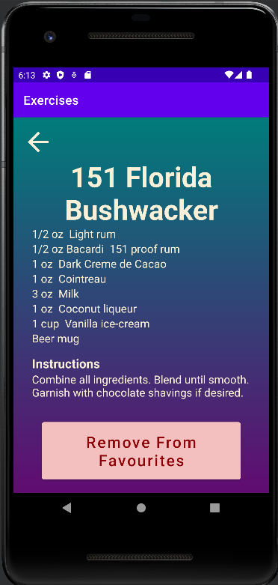

Figure : View Recipe.

## 6.2 Favourite Cocktails

By clicking on the *Favourite Cocktails* button on the Main Menu, the user will be taken to a list of cocktails that have been previously favourited (see figure 9). Each cocktail listing has a View Recipe button, which will direct the user a page with the cocktail’s recipe (see section *6.1.1 View Recipe*).

There is also a back arrow button in the top left hand corner, which will return the user to the Main Menu.

At the top of the screen is a search bar that will search the name of a cocktail in the Favourites list, filtering the Favourites listed with each keystroke. Once the user starts typing, an *X* will appear at the right end of the search bar. By clicking on this, the user will clear the search query.

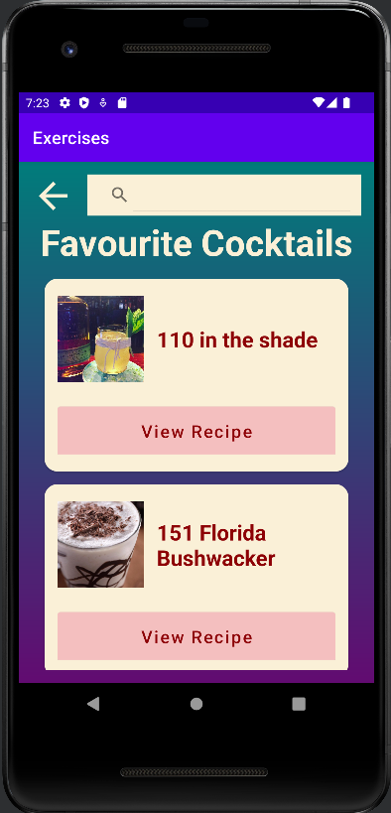

Figure : Favourite Cocktails.